Simple Bank Management System
Developer: Sunil Kumar
Technologies Used: Python, Flask, MySQL, HTML, CSS, Java Script

Abstract
This project is a web-based Simple Bank Management System built to allow users to register, log in, and manage their bank accounts. It facilitates basic banking operations through a user-friendly web interface. The system handles user authentication, account creation, and transaction management securely and efficiently.

Introduction
Banking is an essential service in modern life, and digital banking systems help users manage their finances conveniently. This project enables users to sign up, log in, view account balances, and perform basic transactions such as deposits and withdrawals. It provides a practical understanding of backend web development using Flask and database integration with MySQL.

Objectives
- Enable user registration and authentication
- Allow users to create and manage a bank account
- Allow transactions such as deposits, withdrawals, and transfers
- Maintain account balance accuracy
- Ensure data security using password hashing and session management
- Provide an intuitive and responsive user interface

Technologies and Tools Used
• Python (Flask Framework)
• MySQL Database
• HTML, CSS and Java script for frontend design
• Werkzeug for password hashing
• Flask session management for user authentication
• VS Code for development environment

System Modules

- User Module – Handles user registration, login, and profile management.
2. Account Module – Displays account details and balance.
3. Security Module – Ensures secure login and session-based authentication.

Database Design

The database consists of the following tables:
• Users – id, username, email, password_hash, created_at
• Accounts – account_id, user_id, balance, created_at

Features
- Secure user registration and login system
- Real-time balance updates
- Deposit, withdraw, and transfer functionality
- Simple, clean, and responsive interface
- Error handling for invalid inputs and insufficient balance

Implementation
The backend is developed using Flask, where each route handles specific functionalities such as registration and login. Password hashing is implemented using Werkzeug, and Flask sessions store user login states. MySQL database manages persistent user and transaction data.

Future Enhancements
- Add an admin panel to manage users and transactions
- Implement email/SMS notifications for transactions
- Introduce data visualization for account reports
- Add two-factor authentication for enhanced security

Libraries

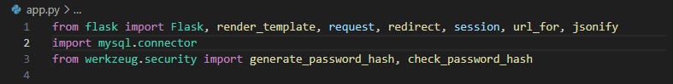

File structure

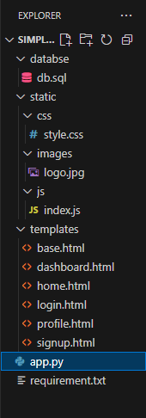

Screen Shots

Home page
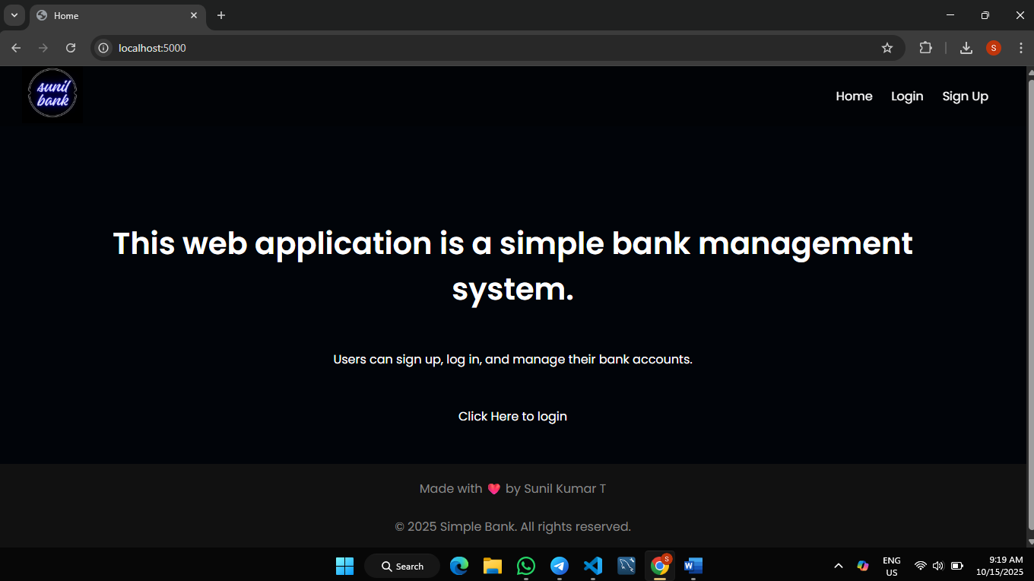

Login page
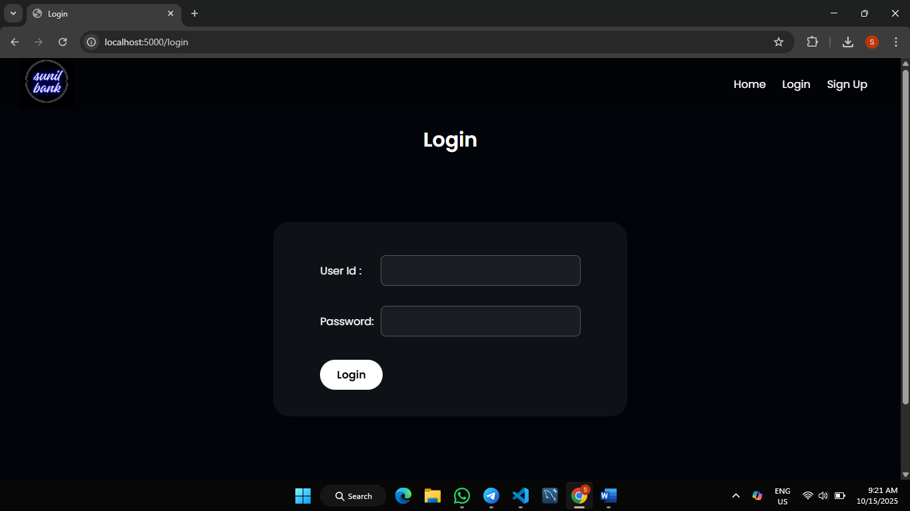
Signup page
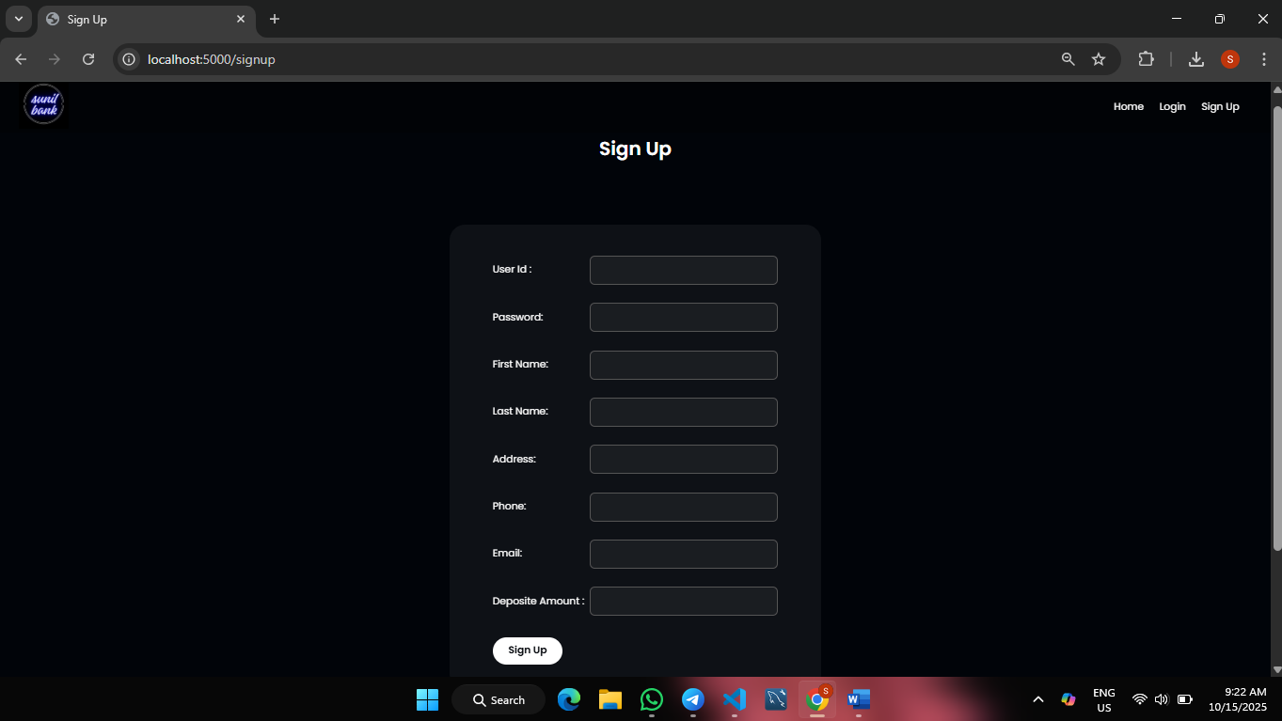

Dashboard page
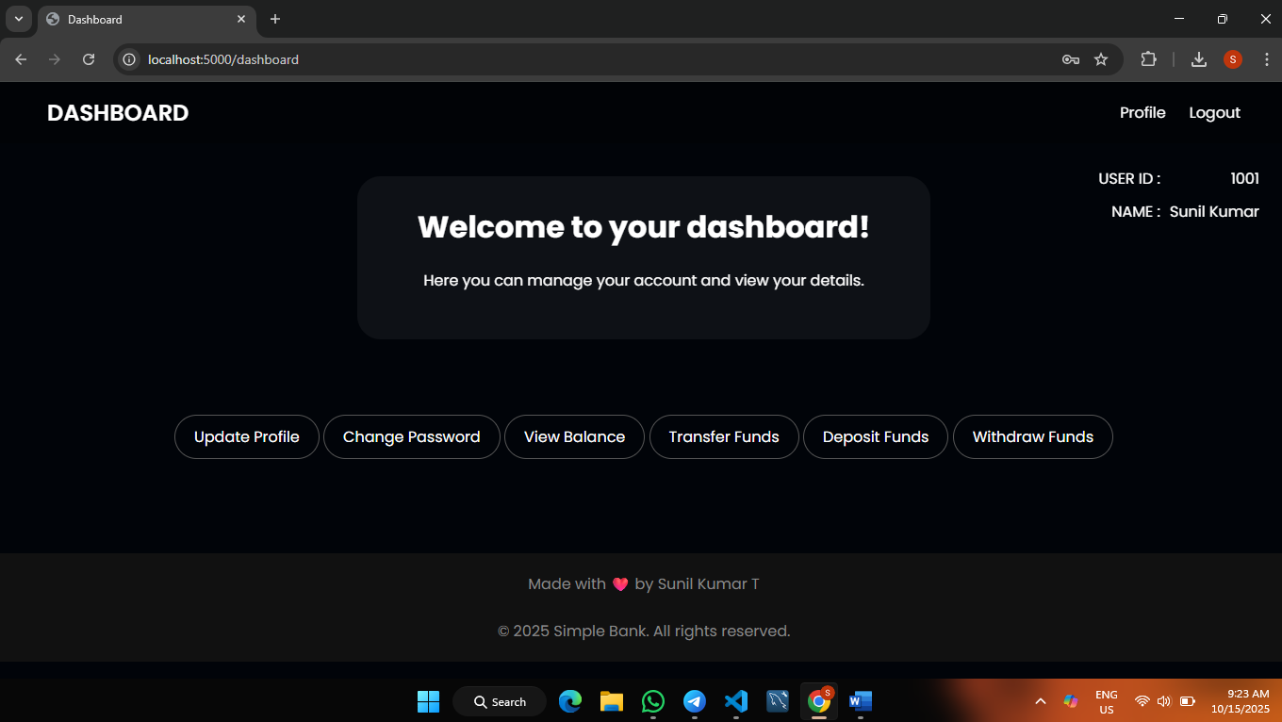

Here we can access the options below
Update profile, Change password, View Balance, Transfer money, Deposit and withdraw.
Profile page

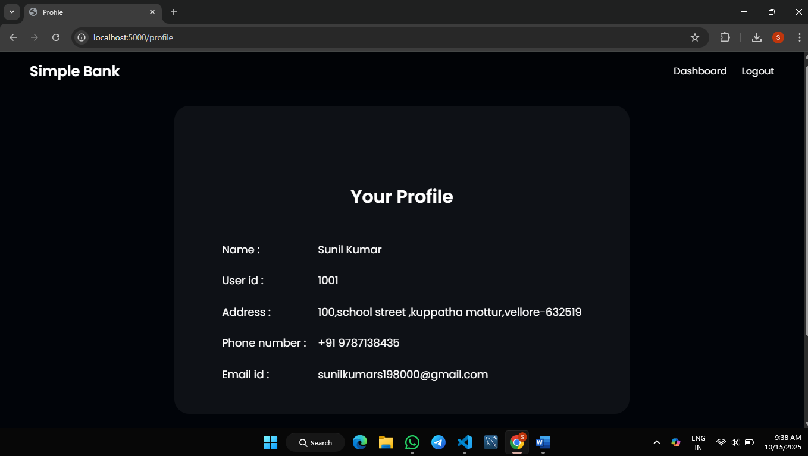

Conclusion
The Simple Bank Management System successfully demonstrates the integration of backend and database concepts using Flask and MySQL. It offers a foundation for understanding authentication, CRUD operations, and secure data handling in web applications. This project can be further expanded into a complete banking application with additional features and stronger security measures.

